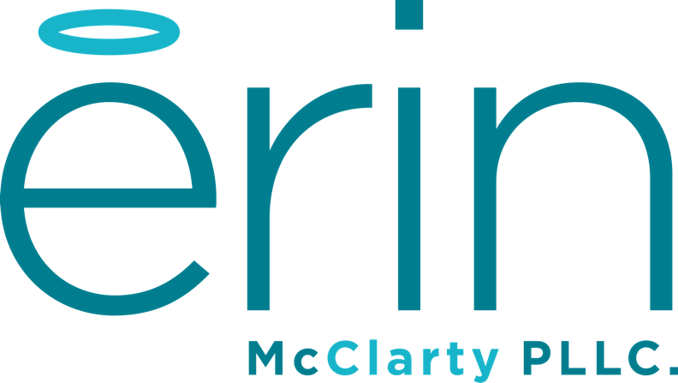

Needs Matrix
Some of us are passionate about a number of things. Which can result in starting a number of projects and businesses. Choosing which project or business to focus on can feel tricky…almost like betrayal. Almost like picking a favorite child or pet! It can be helpful to step back and look at what each business requires. The more requirements one has, the more we might decide to hold off a bit. What I’ve done is list a few things to think about. Feel free to email me if you have any questions or get stuck. Try to write as much as you can.

Current Projects & Businesses

Which projects and/or businesses are you trying to prioritize? List them here.

______________________ ___________________ ___________________

______________________ ___________________ ___________________

 | Complex Idea | Time Requirement | Capital Requirement | Expertise | # Team Members to Add | Developed Business Model | Market Identified | Quick Revenue Generation | Passionate | Can Test Quickly
List project here
List project here
List project here
List project here
List project here
List project here
TOTAL

For each of your projects or businesses rate them under each consideration on a scale of 1-10. With 1 being “Yea, that would be super easy” to 10 being, “Oh, that would be pretty difficult.” Projects or business where you’ve already done something (like developed the business model) rank it lower.

1 2 3 4 5 6 7 8 9 10
Super Easy Most Difficult

Those with the lowest scores may be the easiest to implement right now. That doesn’t necessarily mean that’s the only thing you should think about. But it may help with building momentum and generating revenue.

Legend

Complexity- How difficult do you think it would be it to start the project or business?

Time Requirement- How easy would it be to meet the time requirements?

Capital Requirement- How easy would it be to meet the capital requirements?

Expertise- Do you have, or could you attain, the expertise to get started? How hard?

# Of Team Members to Add- How big of a team is required and would you be able to build it?

Developed Business Model- Do you have a business model already created? If not, how hard would it be to create one?

Market Identified- Do you have a market identified. If not, how hard would it be to identify the market?

Quick Revenue Generation- How easy would it be to generate revenue quickly?

Passionate- How easy would it be to be passionate about the project or business?

Can Test Quickly- Could you quickly test the business or project?

